Copyright for test papers and marking guides remains with *West Australian Test Papers.*

Test papers may only be reproduced within the purchasing school according to the advertised Conditions of Sale.

Test papers should be withdrawn after use and stored securely in the school until Friday December 4th.



**Human Biology**

**Unit 1 & 2**

**2020**

**Marking Key**

|  |  |
| --- | --- |
| **Question** | **Answer** |
| 1 | A |
| 2 | C |
| 3 | C |
| 4 | D |
| 5 | B |
| 6 | D |
| 7 | B |
| 8 | C |
| 9 | A |
| 10 | B |
| 11 | C |
| 12 | B |
| 13 | C |
| 14 | D |
| 15 | A |
| 16 | B |
| 17 | A |
| 18 | D |
| 19 | D |
| 20 | D |
| 21 | B |
| 22 | C |
| 23 | D |
| 24 | A |
| 25 | A |
| 26 | D |
| 27 | B |
| 28 | C |
| 29 | B |
| 30 | C |

**Question 31 (17 marks)**

The diagram below shows the direction of movement of two different substances through the plasma membrane of a cell.

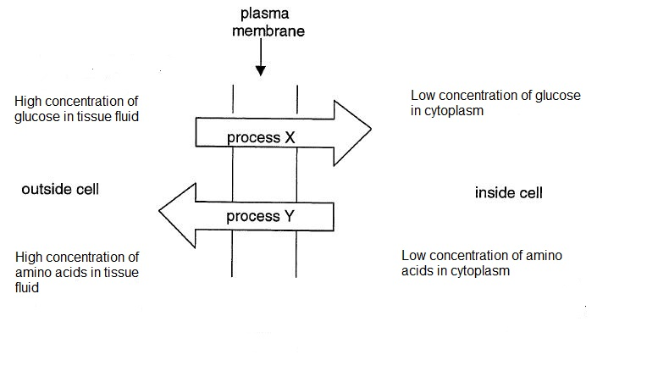

1. Identify: (2 marks)

|  |  |
| --- | --- |
| **Description** | **Mark** |
| (i) Process X- facilitated diffusion | 1 |
| (ii) Process Y- active transport | 1 |
| **Total** | **2** |

(b) Which of the processes X and Y would be affected by the amount of oxygen present in the blood plasma? Justify your choice. (3 marks)

|  |  |
| --- | --- |
| **Description** | **Mark** |
| Process Y | 1 |
| Oxygen required for respiration | 1 |
| Respiration produces energy for active transport to occur | 1 |
| **Total** | **3** |

(c) Name two other methods by which substances move across plasma cell membranes. (2 marks)

|  |  |
| --- | --- |
| **Description** | **Mark** |
| Any two of: |  |
| * Osmosis * Vesicular transport /endocytosis/ exocytosis/ phagocytosis/pinocytosis * Diffusion | 1-2 |
| **Total** | **2** |

(d) Cell membranes are composed of protein and lipid molecules.

(i) On the diagram below clearly label **three** cell organelles that would be involved in the synthesis of protein molecules that may form part of the cell membrane. (3 marks)

Ribosome

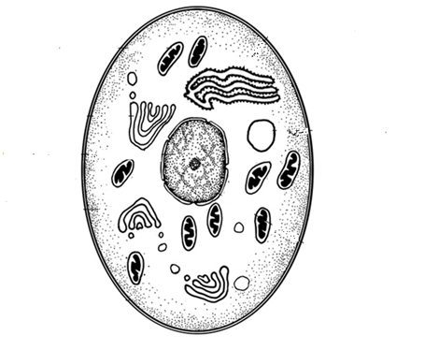

Golgi apparatus

Endoplasmic reticulum

Mitochondria

Nucleus

**Students can label any 3 out of the 5 organelles labelled**

(ii) Briefly describe how each of the organelles you have labelled contributes to

protein synthesis in the cell. (3 marks)

|  |  |
| --- | --- |
| **Description** | **Mark** |
| **Any 3 of the following – must match labels drawn on diagram** |  |
| Nucleus has coded instructions in DNA for the type of protein to be made | 1 |
| Mitochondria provide energy for the process | 1 |
| Ribosomes are the actual sites on which proteins are assembled | 1 |
| Endoplasmic reticulum has many enzymes which catalyse the  synthesis of proteins on the attached ribosomes | 1 |
| Golgi body- packaging/secreting of proteins that have been  produced. | 1 |
| **Total** | **3** |

Enzymes are an example of a protein produced by a cell. They are used as catalysts for

reactions.

(e) Explain how enzymes catalyse specific reactions. (4 marks)

|  |  |
| --- | --- |
| **Description** | **Mark** |
| Enzymes have active sites | 1 |
| That are a specific shape/ configuration | 1 |
| Complementary to substrate/ perfect fit between active site and substrate/ lock and key | 1 |
| Combine to form an enzyme substrate complex | 1 |
| Induced fit model could also be explained. |  |
| **Total** | **4** |

**Question 32 (17 marks)**

The table below gives the relative amounts of DNA present in different cells found within a human body.

|  |  |
| --- | --- |
| **Cell type** | **Amount of DNA** |
| Red blood cell | 0 |
| Skin cell | 6.6 |
| Ova | 3.3 |

1. Account for the fact that the DNA content of a red blood cell is zero. (1 mark)

|  |  |
| --- | --- |
| **Description** | **Mark** |
| Has no nucleus | 1 |
| **Total** | **1** |

1. What is the relationship between the DNA content found in a skin cell and ovum? Give an explanation for this difference. (3 marks)

|  |  |
| --- | --- |
| **Description** | **Mark** |
| DNA content in ovum is half that of a skin cell | 1 |
| Ovum is a gamete that is haploid/ contains only half the number of chromosomes | 1 |
| Skin cells are diploid so would contain more/ double the DNA | 1 |
| **Total** | **3** |

(c) The process of meiosis is involved in the production of gametes. What are the

two forms of gametogenesis called and explain how they differ in the number of

gametes they produce.

(4 marks)

|  |  |
| --- | --- |
| **Description** | **Mark** |
| Spermatogenesis. | 1 |
| produces 4 sperm cells | 1 |
| Oogenesis | 1 |
| one egg cell is produced along with 3 polar bodies | 1 |
| **Total** | **4** |

(d) Sperm production occurs within the testes. Name the structure in which this process takes place and give an advantage of this structure being tightly coiled. (2 marks)

|  |  |
| --- | --- |
| **Description** | **Mark** |
| Seminiferous tubules | 1 |
| Increases area for sperm production | 1 |
| **Total** | **2** |

(e) State two structural differences between a sperm and an egg and for each difference explain how it helps in the process of reproduction. (4 marks)

|  |  |
| --- | --- |
| **Description**  **Any 2 of the following** | **Mark** |
| 1. Difference: sperm has tail, ovum doesn’t | 1 |
| Explanation: for movement through female reproductive tract | 1 |
| 2. Difference: Ovum has more cytoplasm than sperm | 1 |
| Explanation: contains all organelles for cell functioning | 1 |
| 3. Difference: Sperm has acrosome | 1 |
| Explanation: helps sperm to penetrate the ovum | 1 |
| **Total** | **4** |

(f) Explain the importance of fertilisation in sexual reproduction. (3 marks)

|  |  |
| --- | --- |
| **Description** | **Mark** |
| Combines genetic material from two different parents/male and  female parents/egg and sperm | 1 |
| Restores diploid number of chromosomes | 1 |
| Creates variation | 1 |
| **Total** | **3** |

**Question 33 (14 marks)**

In humans oxygen is carried around the body in chemical combination with an iron based compound called haemoglobin. The chemical equation for haemoglobin combining with oxygen is shown below.

Hb + O2 HbO2 (this occurs in the lungs)

HbO2 Hb + O2 (this occurs in the body tissues)

The factor that determines how much HbO2 is produced is the partial pressure of oxygen.

The data below shows the relationship between the partial pressure(pp) of oxygen and the saturation of the haemoglobin molecule.

|  |  |
| --- | --- |
| **Partial pressure of Oxygen (mm Hg)** | **Saturation of haemoglobin (%)** |
| 0 | 0 |
| 10 | 10 |
| 20 | 25 |
| 40 | 70 |
| 50 | 82 |
| 70 | 93 |
| 90 | 96 |

1. Identify the independent variable in the information shown above. (1 mark)

|  |  |
| --- | --- |
| **Description** | **Mark** |
| (partial) pressure of oxygen | 1 |
| **Total** | **1** |

(b) Propose a hypothesis for this study. (1 mark)

|  |  |
| --- | --- |
| **Description** | **Mark** |
| An increase in partial pressure of oxygen increases saturation of haemoglobin | 1 |
| **Total** | **1** |

1. Graph the results from the table above onto the grid provided.(5 marks)

|  |  |
| --- | --- |
| **Description** | **Mark** |
| Title  Axes around correct way  Axes- label and units  Correct scale  Line graph | 1-5 |
| **Total** | **5** |

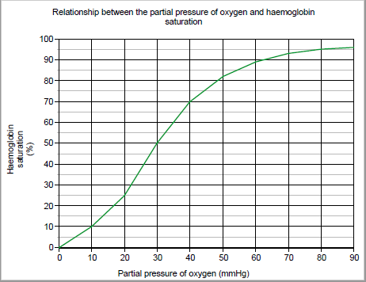

1. Using data from your graph, describe the relationship between partial pressure and the percentage saturation of haemoglobin. (2 marks)

|  |  |
| --- | --- |
| **Description** | **Mark** |
| Direct relationship/ non linear as partial pressure increases so too does Hb saturation. | 1 |
| Specific data points from graph used to support statement | 1 |
| **Total** | **2** |

1. Predict what would happen to the percentage saturation of haemoglobin if the partial pressure of oxygen was increased to 110 mmHg. Justify your prediction. (2 marks)

|  |  |
| --- | --- |
| **Description** | **Mark** |
| Saturation would be 96%/remains high/steady | 1 |
| At high ppO2 percentage saturation starts to level off. | 1 |
| **Total** | **2** |

1. Using the following information explain how oxygen is absorbed into the bloodstream

(3 marks)

Partial pressure of oxygen in the lungs = 100mmHg

Partial pressure of oxygen in the blood that enters the lungs = 40mmHg

|  |  |
| --- | --- |
| **Description** | **Mark** |
| Higher pressure of oxygen in the lungs | 1 |
| ppO2 in blood lower | 1 |
| Oxygen diffuses from higher pressure to lower pressure/ diffuses from lungs into bloodstream | 1 |
| **Total** | **3** |

**Question 34 (9 marks)**

1. What is the sex chromosome configuration for males. (1 mark)

|  |  |
| --- | --- |
| **Description** | **Mark** |
| males : XY | 1 |
| **Total** | **1** |

1. Colour blindness is an example of x-linked recessive inheritance. Using the letters **B** and **b**, determine the genotypes of the following individuals. (3 marks)

(i) Colour-blind male _____________________________________

(ii) Unaffected female ____________________________________

(iii) Unaffected male _____________________________________

|  |  |
| --- | --- |
| **Description** | **Mark** |
| (i) XbY | 1 |
| (ii) XBXB or XBXb (must have both for mark) | 1 |
| (iii) XBY | 1 |
| **Total** | **3** |

(c) Describe why a father with an X-linked disorder cannot pass the condition onto his son (2 marks)

|  |  |
| --- | --- |
| **Description** | **Mark** |
| Y chromosome does not carry colour blindness gene | 1 |
| Sons can only inherit Y gene from father as this is what makes them male. | 1 |
| **Total** | **2** |

(d) Explain how the process of amniocentesis can be used to detect genetic disorders.

(3 marks)

|  |  |
| --- | --- |
| **Description** | **Mark** |
| Removal of amniotic fluid (16th-20th week pregnancy) | 1 |
| Foetal cells found in amniotic fluid | 1 |
| Cells examined for biochemical defects/ chromosomal abnormalities | 1 |
| **Total** | **3** |

**Question 35 (13 marks)**

The data below has been taken from the Australian Bureau of Statistics. It shows the number

of births per age group (of the mother) from the years 2009 to 2017.

(a) Describe and give an explanation for the trends shown by the data in the following

age groups. (4 marks)

|  |  |  |  |  |  |  |  |  |  |
| --- | --- | --- | --- | --- | --- | --- | --- | --- | --- |
|  | **Year** | | | | | | | | |
| **Age** | **2009** | **2010** | **2011** | **2012** | **2013** | **2014** | **2015** | **2016** | **2017** |
| **15-19** | 12702 | 11865 | 11344 | 11420 | 10407 | 9204 | 8574 | 7559 | 7401 |
| **20-24** | 43536 | 43187 | 41769 | 42367 | 41351 | 38558 | 38733 | 37022 | 36117 |
| **40-44** | 11048 | 11710 | 12144 | 12538 | 12931 | 12106 | 12217 | 12501 | 12414 |
| **45-49** | 572 | 604 | 661 | 736 | 670 | 777 | 910 | 1024 | 1022 |

(i) 15-19.

|  |  |
| --- | --- |
| **Description** | **Mark** |
| Reduction in number of births from 2009-2017 | 1 |
| Better understanding of contraception/ more use of contraceptives | 1 |
| Accept any other reasonable answer |  |
| **Total** | **2** |

(ii) 45-49.

|  |  |
| --- | --- |
| **Description** | **Mark** |
| Increase in number of births from 2009-2017 | 1 |
| Women not having children until later age due to staying in workforce/marrying later/waiting until financially secure/ able to access ART | 1 |
| Accept any other reasonable answer |  |
| **Total** | **2** |

|  |  |
| --- | --- |
| **Description** | **Mark** |
| IVF - Embryo inserted | 1 |
| GIFT- gametes inserted | 1 |
| IVF- implanted into uterus | 1 |
| GIFT- inserted into fallopian tube | 1 |
| **Total** | **4** |

(b) Often couples who have issues with fertility turn to assisted reproductive technologies. Explain the main differences between IVF and GIFT. (4 marks)

(c) Most assisted reproductive technologies require the woman to take a fertility drug. Often these drugs contain follicle-stimulating hormone. Using your knowledge of the ovarian cycle in females explain what the purpose of this hormone would be in treating infertility. (3 marks)

|  |  |
| --- | --- |
| **Description** | **Marks** |
| FSH acts on follicles in ovary to begin growth and maturation of follicles | 1 |
| Increased levels of FSH may enable more than one follicle to mature at a time | 1 |
| increases amount of eggs that can be harvested each cycle/ released at ovulation. | 1 |
| **Total** | **3** |

(d) Identify TWO ethical issues associated with the use of assisted reproductive technologies. (2 marks)

|  |  |
| --- | --- |
| **Description –any 2 of** | **Marks** |
| Rights of donor parents | 1 |
| Should children resulting from donor sperm/eggs have access to information about parents | 1 |
| What is done with any extra embryos that are created | 1 |
| Risk of mistakes being made with donor sperm or eggs | 1 |
| Parents choosing sex of embryo before implantation | 1 |
| Accept any other valid answer |  |
| **Total** | **2** |

**Question 36 (14 marks)**

Blood is composed of fluid and cellular components.

(a) Give one function of each component of blood listed in the table below. (2 marks)

|  |  |
| --- | --- |
| **Description** | **Mark** |
| Erythrocytes: carry oxygen around the body bonded to haemoglobin | 1 |
| Leucocytes: defend against infection/part of immune system | 1 |
| **Total** | **2** |

(b) Describe the composition of plasma. (3 marks)

|  |  |
| --- | --- |
| **Description** | **Mark** |
| (91%) water | 1 |
| Contains dissolved substances | 1 |
| Such as – ions/nutrients/ gases/hormones | 1 |
| **Total** | **3** |

(c) When a person sustains a cut on their skin that bleeds explain how platelets

help with the blood clotting process. (3 marks)

|  |  |
| --- | --- |
| **Description** | **Mark** |
| Stick to rough surface of injury | 1 |
| Release fibrin | 1 |
| Attract other thrombocytes/ red blood cells so a plug is built up at injury site | 1 |
| **Total** | **3** |

(d) The following statements refer to the circulatory system of humans. Determine if the statements are true or false and justify your choice. (6 marks)

(i) There is little need for the muscles of the atria to be powerful.

|  |  |
| --- | --- |
| **Description** | **Mark** |
| True | 1 |
| Atria receive low pressure blood from veins | 1 |
| Only need to move/ pump blood down to ventricles/ short distance | 1 |
| **Total** | **3** |

(ii) It is more efficient for the right side of the heart to be completely separated from the

left.

|  |  |
| --- | --- |
| **Description** | **Mark** |
| True | 1 |
| If chambers were not separated deoxygenated and oxygenated blood would mix | 1 |
| This reduces amount of oxygen that would travel to cells/ lowers O2 diffusion gradient of cells | 1 |
| **Total** | **3** |

**Question 37 (14 marks)**

The graph below shows how pregnancy is maintained through the secretion of hormones.

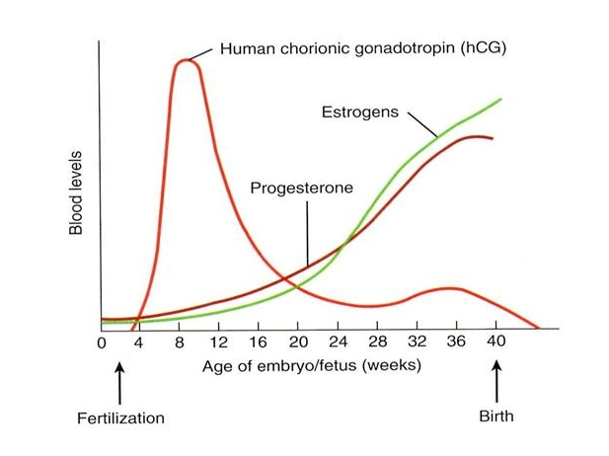

1. Which hormone/s shown above can be used to detect whether or not a woman is pregnant? (1 mark)

|  |  |
| --- | --- |
| **Description** | **Mark** |
| hCG | 1 |
| **Total** | **1** |

(b) Explain the role of hCG in pregnancy (3 marks)

|  |  |
| --- | --- |
| **Description** | **Mark** |
| Maintains the corpus luteum | 1 |
| So that progesterone and oestrogen are secreted | 1 |
| Until placenta is established | 1 |
| **Total** | **3** |

The diagram below shows the movement of blood through a foetal heart. 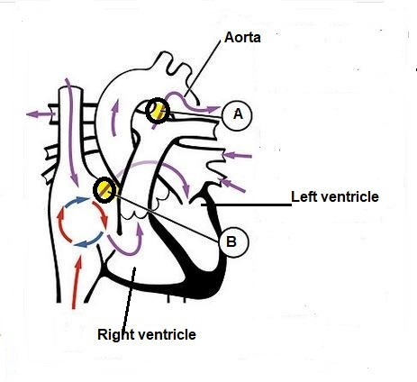

.

(c) The blood flow through a foetal heart is different to that in an adult heart. This is because two areas of the heart have been modified to assist with foetal blood flow. Use the diagram to name and state the functions of the areas labelled A and B. (4 marks)

|  |  |
| --- | --- |
| **Description** | **Mark** |
| A : Ductus arteriosus | 1 |
| Allows blood from pulmonary artery to flow directly into the aorta | 1 |
| B : Foramen ovale | 1 |
| Allows blood to flow from the right atrium to the left atrium | 1 |
| **Total** | **4** |

(d) Describe how the foetal blood system is kept separate from that of the mother.

(2 marks)

|  |  |
| --- | --- |
| **Description** | **Mark** |
| Chorionic villi are surrounded by pools of mother’s blood | 1 |
| Layers of cells separate two blood supplies | 1 |
| **Total** | **2** |

(e) Explain the roles of prolactin and oxytocin in breastfeeding. (4 marks)

|  |  |
| --- | --- |
| **Description** | **Mark** |
| **Prolactin**   * Secreted each time baby suckles * Continues milk production/ stimulates production of milk | 1-2 |
| **Oxytocin**   * Triggers contraction of small muscles surrounding lobules * Milk then ejected into ducts/ let-down | 1-2 |
| **Total** | **4** |

**Question 38 (17 marks)**

The diagram below shows the arrangement of muscles and bones in the upper arm.

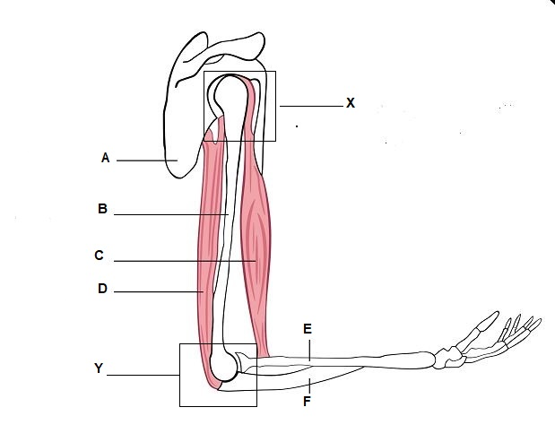

1. State the names of the structures labelled: (3 marks)

|  |  |
| --- | --- |
| **Description** | **Mark** |
| A: Scapula | 1 |
| C: Bicep | 1 |
| E: Radius | 1 |
| **Total** | **3** |

(b) Name the joints labelled X and Y and describe the difference in the range of

movement each joint allows. (4 marks)

|  |  |
| --- | --- |
| **Description** | **Mark** |
| X- Ball and socket  Y- Hinge | 1-2 |
| * Ball and socket joints allow movement in all directions. * Hinge joint only allows movement in one plane/ flexion and extension | 1-2 |
| **Total** | **4** |

(c) The ends of bone are covered by cartilage. State the name of this type of cartilage and describe its function. (2 marks)

|  |  |
| --- | --- |
| **Description** | **Mark** |
| Articular (cartilage) | 1 |
| Provide smooth surface for movement/ reduce friction | 1 |
| **Total** | **2** |

(d) All muscles possess three properties that allow them to work together to create movement. These are elasticity, extensibility and the ability to contract. Using the bicep and triceps muscles to illustrate your answer explain why muscles need these three qualities to function effectively. (5 marks)

|  |  |
| --- | --- |
| **Description** | **Mark** |
| Muscles need to be able to contract so they can pull on bones to create movement | 1 |
| Biceps contracts to flex your lower arm | 1 |
| Muscles need to be able to extend so they can work in opposition, | 1 |
| as biceps flexes/contracts the triceps extends | 1 |
| Need to be elastic as they must be able return to original length after contraction | 1 |
| **Total** | **5** |

(e) As a person ages they often suffer from a condition known as osteoarthritis.

Describe two symptoms and one treatment for osteoarthritis. (3 marks)

|  |  |
| --- | --- |
| **Description** | **Mark** |
| **Symptoms- any 2 of the following**   * Restricted movement * Pain * Presence of bony spurs * Stiffness * Swelling | 1-2 |
| **Treatment- any 1 of the following**   * Medication * Physiotherapy * Surgery/ joint replacement | 1 |
| **Total** | **3** |

**Section Three: Extended answer 20% (40 Marks)**

Answer **one (1)** question from 39 or 40 and **one (1)** question from 41 or 42.

Supplementary pages for planning/continuing your answers to questions are provided at the end of this Question/Answer booklet. If you use these pages to continue an answer, indicate at the original answer where the answer is continued, i.e. give the page number.

Suggested working time: 50 minutes.

Choose **either** Question 39 **or** Question 40.

**Question 39 (20 marks)**

1. Describe in detail the nature and location of the chemical processes involved in aerobic respiration.

|  |  |
| --- | --- |
| **Description**  **Nature** | **Marks** |
| * releases energy * requires oxygen * oxygen + glucose 🡪 carbon dioxide + water (accept description/diagrammatic form) * ATP * 36-38 ATP per glucose molecule | 1-5 |
| **Description**  **Location** |  |
| * first stage/glycolysis takes place in cytoplasm * main site/Krebs cycle is mitochondria * most ATP produced in mitochondria | 1-3 |
| **Total** | **8** |

1. Digestion involves the breakdown of large molecules into smaller ones so that nutrients can be supplied to cells in a form that can be used for metabolic processes. Explain how carbohydrates, proteins and fats are mechanically and chemically digested. (12 marks)

|  |  |  |
| --- | --- | --- |
| **Component** | **Description** | **Mark** |
|  | **Mechanical**   * Chewing/mastication * Churning * Peristalsis in small intestine * Bile salts emulsify fats | Max 3  1-4 |
| Carbohydrates | **Chemical:**   * Salivary amylase * Pancreatic/intestinal juice amylase * Carbohydrates broken down monosaccharides (named example) | 1-3 |
| Proteins | **Chemical:**   * Pepsin /gastric protease * Pancreatic/intestinal juice protease * Proteins broken down into amino acids | 1-3 |
| Fats | **Chemical:**   * Pancreatic juice contains lipases * Intestinal juice contains lipases * Fats broken down into fatty acids and glycerol | 1-3 |
|  | **Total** | **12** |

**Question 40 (20 marks)**

(a) Excess proteins are broken down in the body. The nitrogenous waste compounds produced from these proteins are then excreted. Describe the processes involved in breaking down proteins. Include in your answer a description of how and where the nitrogenous waste compounds are produced, how they are transported and how they are excreted. (10 marks)

|  |  |
| --- | --- |
| **Description** | **Mark** |
| **How and where broken down**   * Proteins broken down to amino acids * Amino group removed from amino acid * Converted to ammonia * Ammonia converted into urea by adding CO2 * Deamination occurs in the liver | 1-5 |
| **How transported:**   * Urea moves into blood plasma * Transported to kidneys | 1-2 |
| **How excreted- Any 3 of the following**   * Filtration occurs in glomerulus * Urea moves into Bowmans capsule * Urea diffuses into filtrate in other regions of the nephron * Urine containing urea excreted out of body via urethra * Small amounts also lost as sweat | 1-3 |
| **Total** | **10** |

(b) Pepsin is an enzyme that is released into the acidic environment of the stomach.

Pepsin assists the breakdown of proteins to amino acids. Explain how changes in

temperature and pH levels of the stomach will affect the action of pepsin in breaking

down proteins. (10 marks)

|  |  |
| --- | --- |
| **Description** | **Mark** |
| **Temperature**   * optimum temperature/ 37⁰C * increase temp will alter the shape of the active site * enzyme denatures * less successful collisions/enzyme substrate complexes * decrease temp will decrease kinetic energy * less successful collisions/enzyme substrate complexes | 1-6 |
| **pH:**   * optimal pH/ acidic pH * increase/decrease alters the shape of the active site * enzyme denatures * less successful collisions/enzyme substrate complexes | 1-4 |
| **Total** | **10** |

**Question 41 (20 marks)**

(a) The male reproductive system consists of a number of structures that all contribute to the production and transport of sperm. Name and explain the role of the three accessory glands found in the male reproductive system. (12 marks)

|  |  |
| --- | --- |
| **Description** | **Mark** |
| All 3 glands produce the semen in which sperm are contained | 1 |
| **Names**   * Seminal vesicles * Prostate gland * Cowper’s/ Bulbourethral gland | 1-3 |
| **Seminal vesicles**   * Secretes a thick alkaline fluid * Rich in sugar * Provides energy for sperm cells | 1-3 |
| **Prostate gland**   * Secretes a thin milky fluid * Alkaline * Neutralises the acidity of vagina / cervical fluids | 1-3 |
| **Cowper’s gland**   * Secrete mucous * For lubrication of sperm / aid movement of sperm | 1-2 |
| **Total** | **12** |

(b) Lifestyle choices of a pregnant woman can often affect the development of a foetus. Explain how drinking alcohol, smoking cigarettes, and dietary choices can impact foetal development. (8 marks)

|  |  |
| --- | --- |
| **Description** | **Mark** |
| **Alcohol- Any 3 of the following**   * Teratogen. * Foetal alcohol syndrome (FAS)/ Foetal alcohol spectrum disorder (FASD). * Malformations of foetus. * Foetal nervous system development affected. * Under nourishment of foetus. * Facial deformations. | 1-3 |
| **Smoking- Any 3 of the following**   * Changes to baby’s brain and lungs * Reduced oxygen supply * Retarded growth and development * Increased risk of cleft palate and lip | 1-3 |
| **Diet- Any 2 of the following**   * Lack of folic acid can lead to spina bifida and other neural tube defects/ autism * Lack of calcium in the diet / deficiency of Vitamin A can lead to bone deformities. * Listeriosis / Listeria infection caused by eating contaminated food may cause miscarriages or stillbirths. * High mercury from fish may have effects on brain and nervous system   **Accept any other reasonable answers** | 1-2 |
| **Total** | **8** |

**Question 42**

(a) Describe the structure of DNA and the main steps in DNA replication in a cell. (11 marks)

|  |  |
| --- | --- |
| **Description** | **Mark** |
| **Structure- any 5 of the following**   * DNA consists of nucleotides * sugar, phosphate and a nitrogenous base * form of a double-helix * Adenine(A), Thymine(T), Guanine(G) and Cytosine(C) * The backbone is made up of a deoxyribose sugar and phosphate * A-T/T-A/ and C-G / G-C * weak hydrogen bonds | 1-5 |
| **Replication- any 6 of the following**   * DNA helicase breaks hydrogen bonds * DNA unwinds/unzips * DNA strand is copied/acts as template * free nucleotides * (nucleotides) bond with complementary bases * one direction only * DNA polymerase join nucleotides * Any other relevant key info: Semi-conservative process/ Okazaki fragments/ leading and lagging strands/ Ligase joins short stretches of DNA together | 1-6 |
| **Total** | **11** |

(b) During embryonic development the inner cell mass of the blastocyst will differentiate. The name given to a cell that can differentiate into any type of tissue is a ‘stem’ cell. Name the 3 types of stem cells, describe their potency and explain where they can be found. (9 marks)

|  |  |  |  |
| --- | --- | --- | --- |
| **Name** | **Potency** | **Location** | **Mark** |
| Totipotent | Can become any type of cell | Zygote | 1-3 |
| Multipotent | Can become a cell of a particularr tissue | embryos/adult tissue | 1-3 |
| Pluripotent | Can become several types of cell | Inner cell mass/blastocyst | 1-3 |

**End of Section Three**